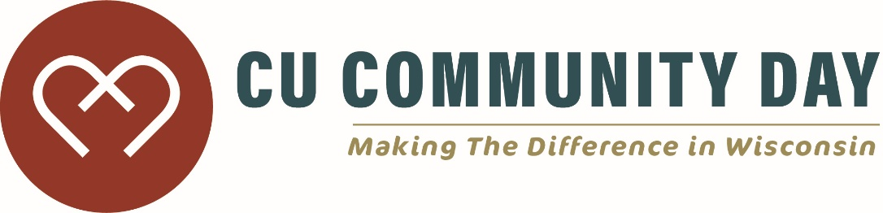

This Media Release (“Release”) is effective immediately as of the date signed by volunteer, and
provided by the undersigned volunteer (referred to as “I”, “me”, or “my”) to NAME, and its directors,
managers, officers, employees, and agents (collectively referred to as “NAME”).

I hereby grant NAME permission to use my photograph, video, name, and/or quotation in marketing and
promotional initiatives, including, but not limited to, print advertising, articles, brochures, TV, Internet,
etc. I agree to hold NAME harmless for any claims arising from the use of my photograph, name, video,
and/or quotation.

Name (Please print):
_____________________________________________________________________________________
Address:
_____________________________________________________________________________________

Phone: (_____) ____________________________

Signature:
____________________________________________________________________________

Witness:
______________________________________________________________________________

Date: _________

